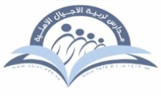
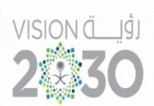

Kingdom of Saudi Arabia Tarbeat Al –Ajial International Schools

Ministry of Education American Section
Hafr Al Baten Directorate
2024/2025

Student’s name |  | Grade | 3
Subject | Computer | Week No. | 2
Lesson Title | Inside a Computer | 1st Semester Work sheet No. | 2
Instruction: Match the following according to their usage.

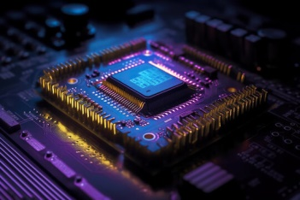 | VIDEO CARD
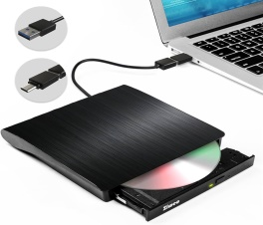 | LAPTOP BATTERY
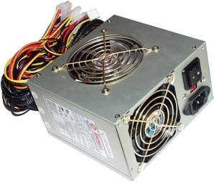 | CENTRAL PROCESSING UNIT
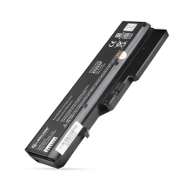 | EXTERNAL DISC
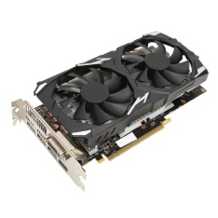 | POWER SUPPLY

